UNIVERSITY
OF WOLLONGONG IN DUBAI

USW Dubai in partnership with UOW Dubai

Jebel Ali Gardens Student Residences

The University of South Wales Dubai in partnership with UOWD, provides a number of residence options that each offer a comfortable environment for study and relaxation. Our accommodation houses undergraduate, postgraduate, and English study students in separate buildings for male and female residents. We provide a clean, safe and secure living option in Dubai, and all of our residences are overseen by live-in Residence Supervisors and student Residence Assistants.

For more information, please contact dubai.admin@southwales.ac.uk / +971 4 8054000

Jebel Ali Gardens
The Residences are located in Jebel Ali Gardens (approximately 20 minutes by bus from Dubai South). The majority of apartments in Jebel Ali Gardens are 3-bedrooms. Most bedrooms are allocated on a shared-basis, 2 students per bedroom.

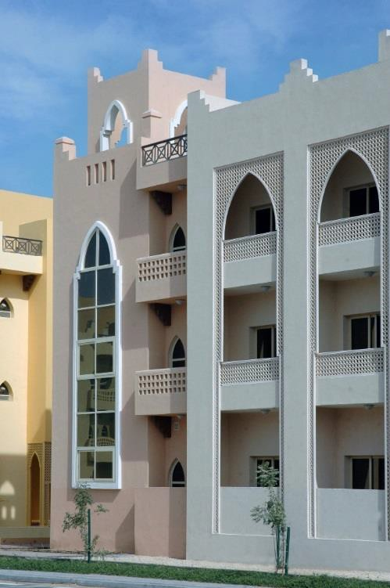
About the Jebel Ali Gardens
  - It is within a short walking distance from The Ibn Battuta Shopping Mall, which houses more than 200 shops including a hypermarket, cinemas and amusement arcades, money exchanges, banking services, restaurants, cafes and food courts
  - Sports and recreation facilities are part of the facilities provided by the Complex Management and include a swimming pool, cricket pitch, football pitch, tennis courts and a basketball court
  - Sports equipment such as basketballs and footballs, tennis racquets
and balls, and bicycles are free of charge
  - Designated parking lots are available for privately owned transportation such as cars and motorbikes at no extra charge.

Residence Fees
Fees are determined by the programme and duration in which you are enrolled, and the location and type of flats requested (or assigned).

Since availability is limited, early registration is recommended to secure University accommodation. Private and family accommodation is not available in the UOWD Residences.

Residence fees include the following items:
- Fully furnished apartments
- Internet access and TV with cable service
- Equipped kitchens with appliances such as stove, refrigerator, microwave, water cooler
- Cleaning services and laundry facilities
- Transportation to/from UOWD several times a day, including evenings for postgraduate classes
- Residence Supervisors providing on-site supervision
- A community lifestyle, encouraging participation in formal and informal social and sporting activities.
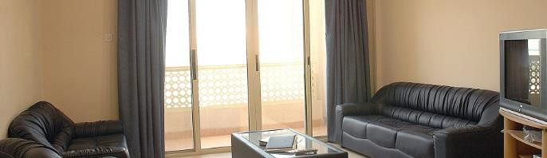

The following items are not included in the fees and students need to provide this by themselves:
- Computers
- Bed linen, pillows, blankets, towels
- Plates, cups, utensils, pots/pans, cooking utensils
- Bedside lamp, electrical adaptors, extension cords
- Laundry soap, shampoo, soap, toilet paper, deodorant, toothpaste
- Other personal items as required.
- Students are also required to purchase their own groceries and prepare their own meals or order meals from nearby restaurants.

Transportation

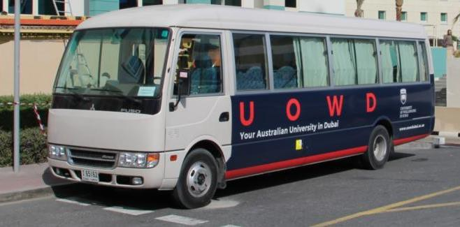
A regular bus service runs direct to the campus from Dubai's Ibn Battuta Metro Station (Station 39). From Ibn Battuta Metro Station students can take a 20-minute bus ride to USW Dubai campus. On completion of Dubai's Metro system, Metro Route 2020 will travel from Dubai Marina to Expo 2020 Metro Station, taking just 16 minutes. From Expo 2020 Metro Station visitors will be able to take a 10-minute bus ride to USW Dubai campus.

Outside of campus studying time, students can take advantage of a free bus service to Dubai Knowledge Park, near Dubai Internet City. UOWD provides an air-conditioned Residence Shuttle Bus services between the Jebel Ali Gardens and the Dubai Knowledge Park several times a day, including an evening service for postgraduate students. This is a free transport service run by UOWD.

RTA public transportation is a safe, clean and inexpensive way for students to travel around the city. The public transportation system covers most of Dubai and students can avail of a discount by showing their Student ID card when they board the bus.

