University of South Wales
Strategic Equality Plan Annual Report
1st April 2020 to 31st March 2021
First report of the
Strategic Equality Plan 2020/21

Should you require this document in an alternative format or if you have any queries relating to this report, please contact:

University Secretary’s Office
governance@southwales.ac.uk

Mae’r ddogfen hon ar gael yn Gymraeg
This document is available in Welsh
- Introduction and background

Under the Equality Act 2010 (Statutory Duties) (Wales) Regulations 2011 the University is required to develop a Strategic Equality Plan (SEqP) and publish an Annual Report by the 31st March each year. The report must cover the period of 1st April to 31st March of the previous year.

The SEqP Annual Report must detail:

- The steps we have taken to identify and collect relevant information;
- How we have used this information to meet the three aims of the public sector duty;
- The reasons for not collecting relevant information;
- A statement on the effectiveness of the arrangements for identifying and collecting relevant information;
- Progress towards fulfilling each of our equality objectives;
- A statement on the effectiveness of the steps we have taken to fulfil each of our equality objectives;
- Specified employment information.

The University of South Wales (USW) Group had a SEqP for 1st April 2020 to 31st March 2024. This is the first Annual Report for the SEqP. It is for the University of
South Wales and covers the period 1st April 2020 to 31st March 2021. There are separate annual reports for the Royal Welsh College of Music & Drama and The College Merthyr Tydfil.

The 2020 to 2024 SEqP outlined six Strategic Equality Objectives for the USW Group. Details of these objectives and progress towards meeting them is outlined in Appendix 1 a detailed table of progress. Appendix 2 of this report contains the specified statistical Equality, Diversity and Inclusion (EDI) Employment Information required; Appendix 3 contains EDI statistical data of the University of South Wales Student population for this period.

- Equality Governance at University of South Wales

The EDI agenda at USW is championed by the University Secretary. The University Secretary chairs the Equality & Diversity Steering Group (EDSG), which meets termly and has representation from all departments, faculties, Trade Unions, Students' Union, The College Merthyr Tydfil and the Royal Welsh College of Music and Drama. The group considers all equality issues and protected characteristics, oversees compliance with the Equality Act 2010 and provides strategic direction for the USW Group’s equality agenda. EDSG has overarching responsibility for the implementation and review of the SEqP.

In addition to EDSG, the University has equality sub groups that are responsible for progressing the equalities agenda for specific protected characteristics.

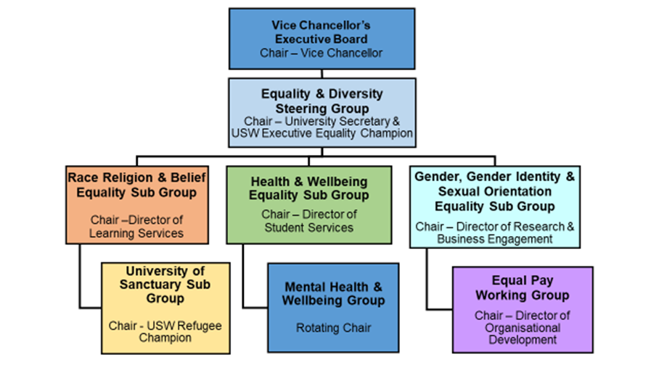

All equality subgroups meet termly and feed into EDSG. They are chaired by senior colleagues and have representation from faculties, departments, the Students’ Union and Trade Unions.

- USW Commitment

Our commitment to equality is at the heart of what we do at the University of South Wales. We are committed to creating and maintaining an inclusive learning and working environment, where equality is advanced, diversity is valued, there is equitable access to success and discriminatory behaviour is not tolerated. In short, a working and learning environment in which everyone can feel valued for who they truly are.
We will put these values into practice with our equality objectives and the actions that we will take across our activities to prevent harassment and discrimination, promote equality of opportunity and foster greater understanding between different groups of people. Specifically in relation to the protected characteristics of age, disability, gender identity, pregnancy and maternity, race, religion and belief, sex and sexual orientation, through an intersectional lens, within the context of our duties under the Equality Act 2010.
Informed by national and wider expectations and requirements of the Higher Education sector, such as the QAA Code and the EU Accessibility Directive, and is a framework that supports our colleague and student communities to develop, and celebrate, our roles as Global Citizens.

- Identifying, Collecting & Using Relevant Information

  - The Steps Taken to Identify and Collect Relevant Information

Under the Equality Act statutory duties for Wales, equality monitoring data of colleague and students is classed as ‘relevant information’ to support the Strategic Equality Plan.

USW monitors all protected characteristics of colleague through an online recruitment system and HR system. Applicants are able to input their equalities data confidentially as part of the application process. This enables HR to produce yearly reports on the success rate of candidates through all stages of the recruitment process anonymously by protected characteristics. This data is presented within Appendix 2 of this report. The HR system contains a ‘self-service’ option for existing colleague to provide their own equality data.

Student enrolment takes place at the start of each academic year through an online system, which includes equality monitoring for all protected characteristics. This data is stored securely and used anonymously to report on student populations of equality groups, as contained within the Student Equality Data Report in Appendix 3. Both this and the Employment Information reports are presented to the EDSG, the relevant Equality Sub Group and the USW HR Committee each year for analysis and scrutiny. They are used to assess trends and imbalances and inform development
of the equalities agenda. The Strategic Equality Plan 2020/2024 has clear actions to strengthen the use of student equality data to assess and develop plans which support the student experience (Action 3.4).

  - How the institution has used relevant information to meet the public sector duty

All actions within the Strategic Equality Action Plan have been developed based upon relevant information gathered through consultation and engagement and detailed analysis of colleague and student data, in addition to other relevant equalities information.

USW's six Strategic Equality Objectives, along with the detailed Strategic Equality Action Plan that underpins these objectives, all focus upon meeting the three aims of the public sector duty:

- Eliminate unlawful discrimination, harassment and victimisation;
- Advance equality of opportunity between different groups;
- Foster good relations between different groups.

Relevant equality information is used to monitor implementation of the duties and, where relevant, features in the action plan table of progress (Appendix 1).

2020/21 saw the University undertake its first full Equal Pay Review inclusive of the characteristics Disability, Gender & Age, Ethnicity, Sexual Orientation, Religion and or Belief, with full consideration of both mean and median pay gaps, publishing its findings in May 2020 with a full set of recommendations across the protected characteristics underpinned by an action plan.

  - Reasons for Not Collecting Relevant Information

The University collects all protected characteristics for colleague and students, with the exception of the following:

Pregnancy and Maternity
Information on pregnancy/maternity for students is not collected during enrolment. However, USW supports students who are pregnant or have recently given birth through its guidance for students on pregnancy, maternity, paternity and adoption and through the Student Advice Zones. Human Resources holds information on colleague on pregnancy/maternity for the purposes of administering maternity leave.

Marriage and Civil Partnership
Data on marital and civil partnership status is currently collected for colleague, but not for students. As marriage and civil partnership is not a protected characteristic for the higher education provisions, there are no plans at present to introduce monitoring of this characteristic for students. For both colleague and students, the gender-neutral title ‘Mx’ is available for use in both systems.

  - Statement on the Effectiveness of Arrangements for Identifying and Collecting Relevant Information

Significant efforts are made to identify, collect, analyse and use relevant information. The arrangements in place for this are effective, with new ways of using relevant information being developed, reviewed and revised regularly.

The robust equality governance structures in place at the University ensure that there is detailed focus upon examining the evidence base for equality and inclusion priorities and analysis of the impact of actions undertaken, in addition to understanding and implementing research and good practice guidance.
- Strategic Equality Objectives – Progress Report

In line with our statutory duties, Appendix 1 provides details of progress we have made towards fulfilling our 6 equality objectives for 2020/21 as outlined below:

OBJECTIVE 1 - We will build a culture of inclusion by promoting dignity, respect, fairness and wellbeing within the University and College communities.

OBJECTIVE 2 - We will mainstream equality, diversity and inclusion into University and College decision-making, policies, practices and procurement.

OBJECTIVE 3 - We will embed equality, diversity and inclusion into the design and delivery of our curriculum, courses and assessment methods.

OBJECTIVE 4 - We will extend our attractiveness as a university and college of choice for students and colleague from diverse backgrounds, cultures and identities

OBJECTIVE 6 - We will take action to reduce the pay gaps at USW and The College.

These actions are also USW’s Gender Pay Action Plan. In compliance with the Equality Act Specific Duty on pay differences we publish a Pay Policy Statement that is reviewed annually

- Conclusion

This report reflects upon progress during the first year of USW’s Strategic Equality Plan for 2020 to 2021, against a backdrop of a Global pandemic. There was also a very significant change relating to the murder (in the USA) of George Floyd (May 2020) and the resurgence of Black Lives Matter (BLM). The scale of change was unprecedented, with colleague and students rising to the challenges of adapting to new ways of learning and teaching as a result of the pandemic.

This report highlights achievements during this period, along with areas that require additional focus. Whilst it is recognised that there is still much further work to be done towards our strategic equality objectives, the work undertaken during the first year of the Strategic Equality Plan provides a good basis on which to move forward.

