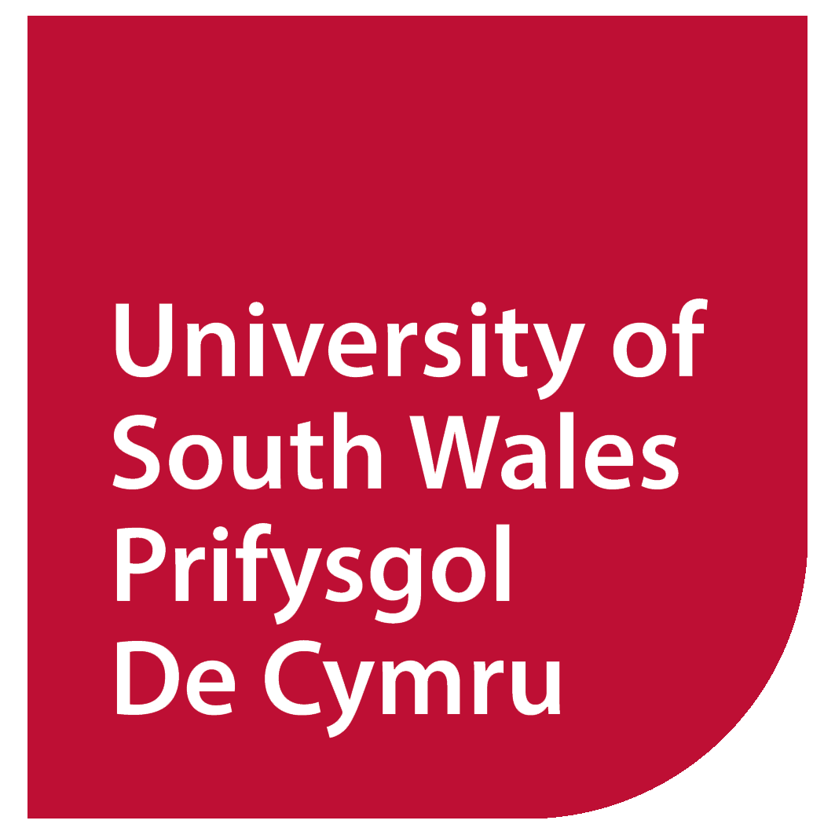
ANNUAL PAY POLICY STATEMENT AND
SENIOR REMUNERATION 2024

The University of South Wales (including the Royal Welsh College of Music and Drama Ltd.) has a Pay Policy which is reviewed each year, and which sets out the principles that are followed in respect of the pay of its colleagues, identifying the approach taken for senior colleagues pay and that of other University colleagues.

As specified in the Pay Policy for colleagues, other than senior colleagues, salaries are identified in line with the role evaluation methodology, which ensures parity across similar roles in the organisation and equal pay. The UCEA 51 point pay spine is used for these staff with incremental progression points, the highest salary being £68,857 per annum.

Where it is considered that the role needs to be reviewed in terms of its remit, responsibility and/or salary, there is the opportunity to be considered under the role evaluation scheme – requests for review can be submitted by individuals or their managers. This scheme is used where the review is not part of a restructure or reorganisation proposal.

The University also operates a Development and Performance Review scheme (DPR), whereby objectives and outcomes are discussed and agreed, appropriate learning and development needs identified and discussions around career development occur. The principle of the scheme is that this is an ongoing discussion between team members and their managers.

As detailed in the Pay Policy, for senior posts the annual review of pay is considered by the Remuneration Committee (for the Vice Chancellor) and the Culture, People and Values Committee for other senior staff, which includes members of the Executive, Directors, Deans and the College Principals. Decisions are based on benchmarking data provided through the UCEA senior salary report, with consideration in respect of equity and parity of pay internally amongst the senior roles.

Recommendations for pay reviews are presented to the Culture, People and Values Committee by the Vice Chancellor, and committee members have the opportunity to scrutinise the recommendations to ensure parity and fairness as well as understand the rationale for any proposals. It is general practice that senior staff receive the equivalent percentage increase on salary as that awarded to other staff via the UCEA national negotiations, however that is included in the recommendations by the Vice Chancellor. If a basic increase is proposed, or there are related performance concerns, there is scope to not apply an increase, for example.

There are 10 senior posts with a remuneration package of more than £100,000, based on basic pay plus any allowance for additional responsibility as at 31 July 2024.

